

Installation of AccentroniX App:

Step 1:
Go onto “Play Store” on your cell phone.

Step 2:
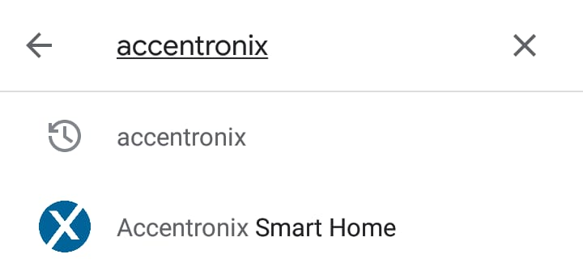
Search for “AccentroniX Smart Home”

Step 3:
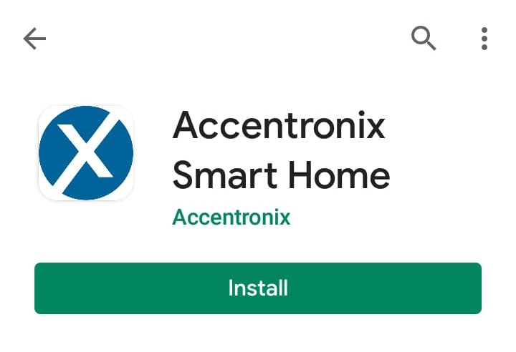
Install “AccentroniX Smart Home”

Step 4:
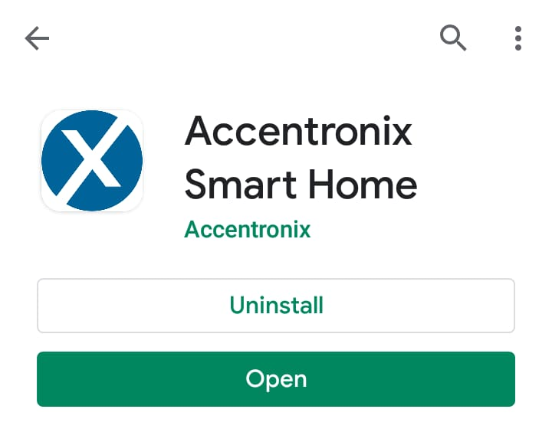
Click on “Open”

Step 5:
Enter YOUR cell phone number that is loaded onto the Access Control and click on “Register”.
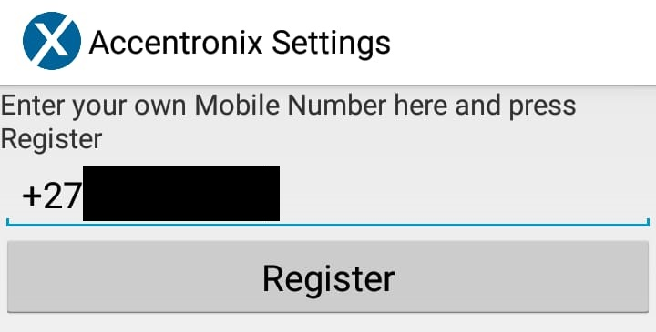

NOTE:
After clicking on “Register”, This screen will appear:
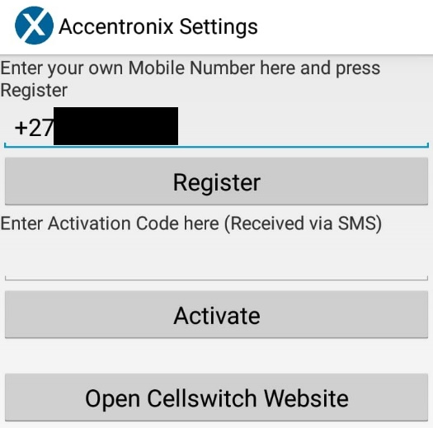

Step 6:
Our server will now send an SMS to the number you entered.
The SMS will contain a code:
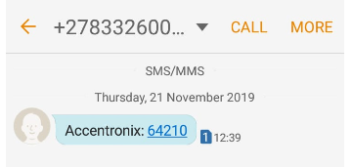

Enter this code here and click on “Activate”.
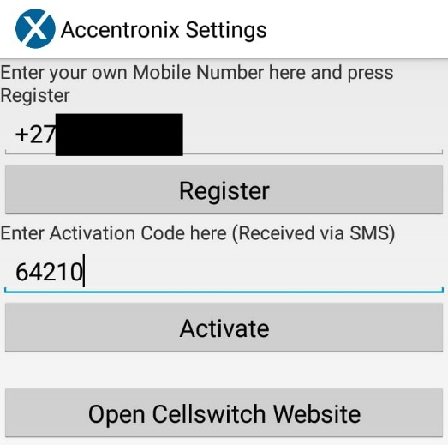
Click here after code has been entered.

Enter Code

Step 7:
This screen will appear with all the units that your cell phone number has access to.
Click on the device that you would like to control.
For Example – AccentroniX Door
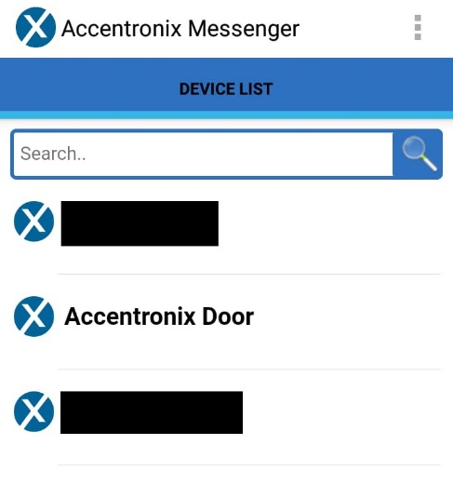

NOTE:
After clicking on the device that you want to control, this screen will appear.
Click on the “Control” button to open the gate.
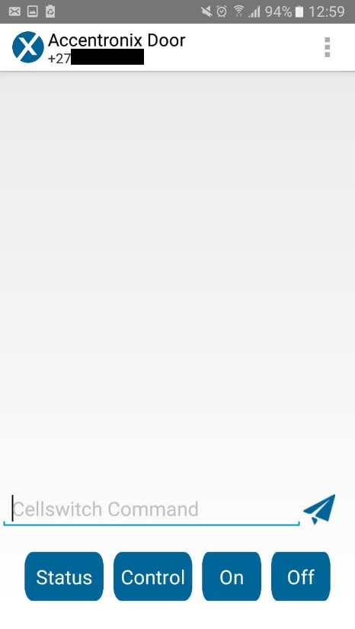

Click to open gate

Step 8:
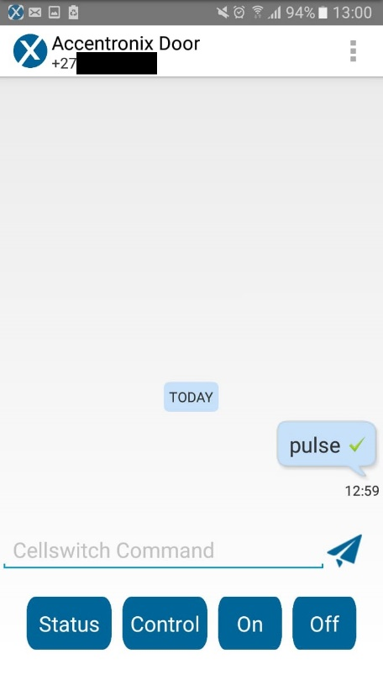
Once you have clicked on the “Control” button, this screen will appear:

This will appear after you click on the “Control” button.

Step 9:
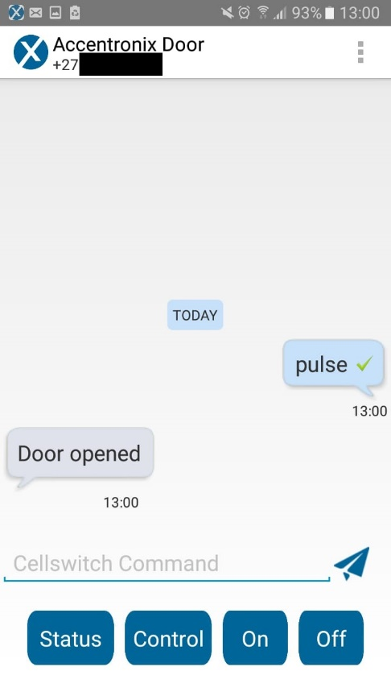
Seconds after you have clicked on the “Control” button, your gate will open, and this will appear:

This is confirmation that the gate has opened.

If the above is unclear, please contact our office for technical support:
Office number: 087 550 3479
Technical Whatsapp Help Line: 063 631 0314
Technical Email Address: support@accentronix.co.za

